**Bean Scopes & Lifecycle**

What Is a Singleton?

* Spring Container creates only one instance of the bean, by **default**
* It is cached in memory
* All requests for the bean will return a SHARED reference to the SAME bean

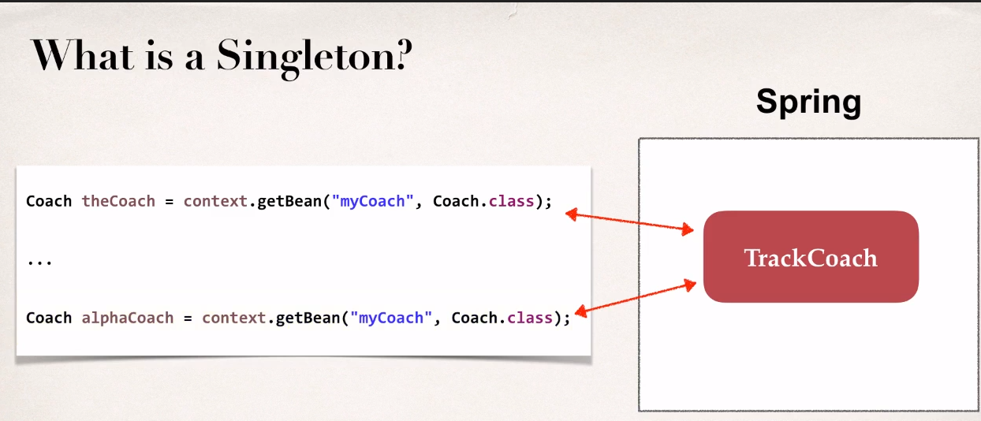

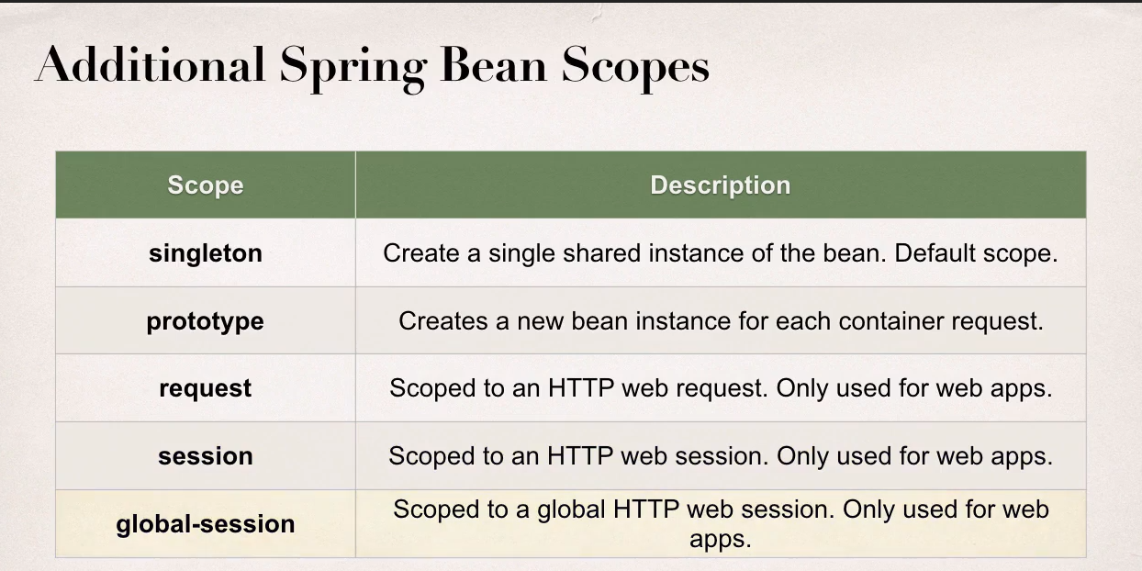

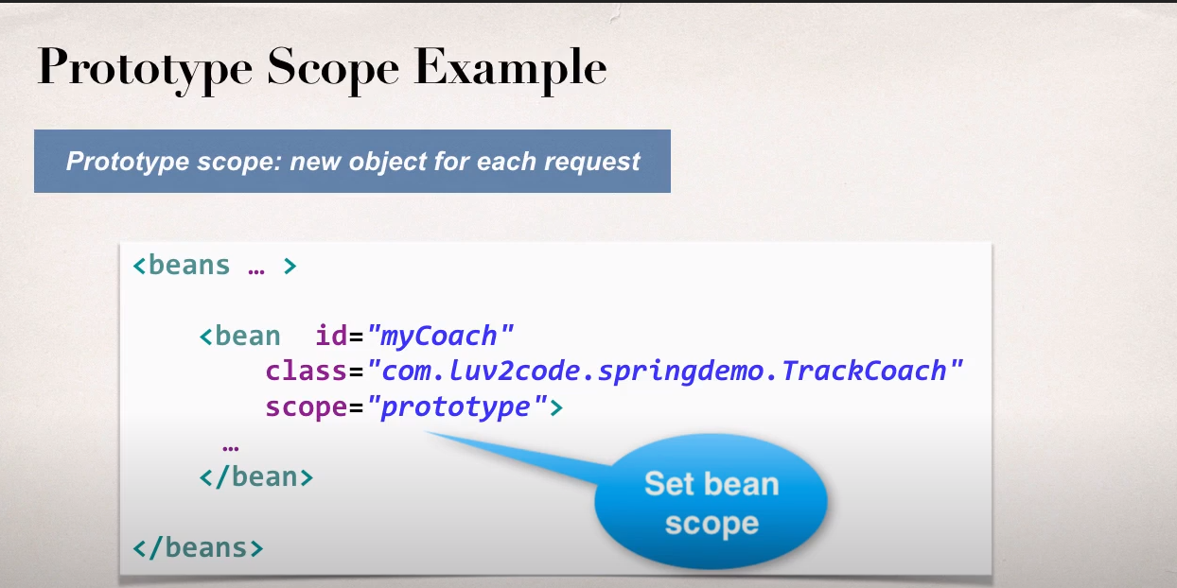

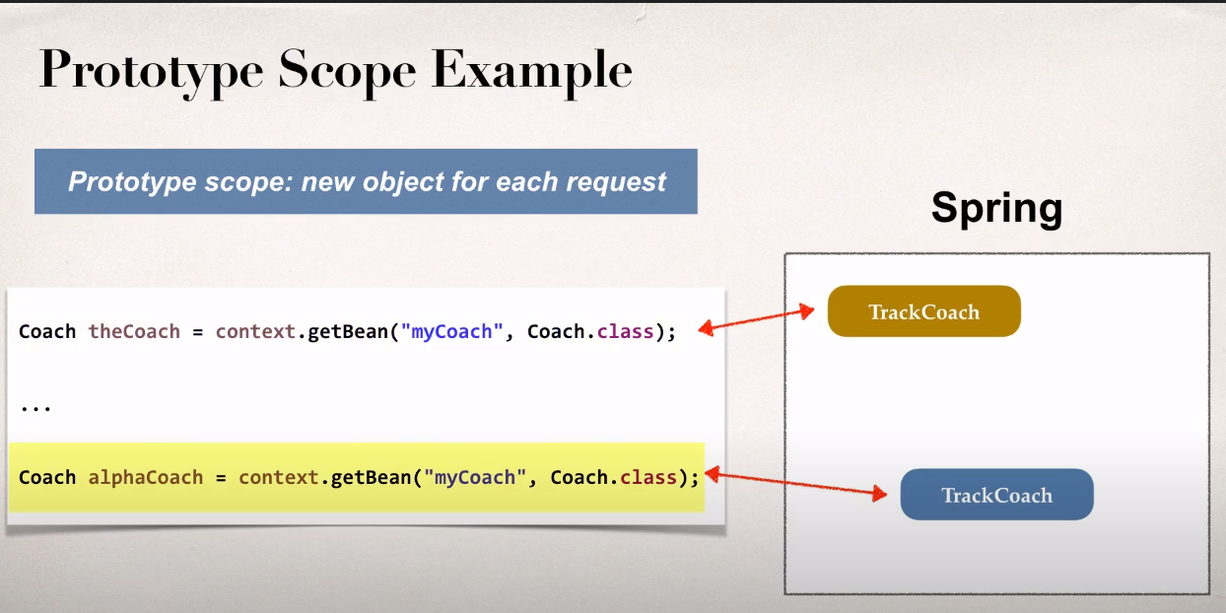

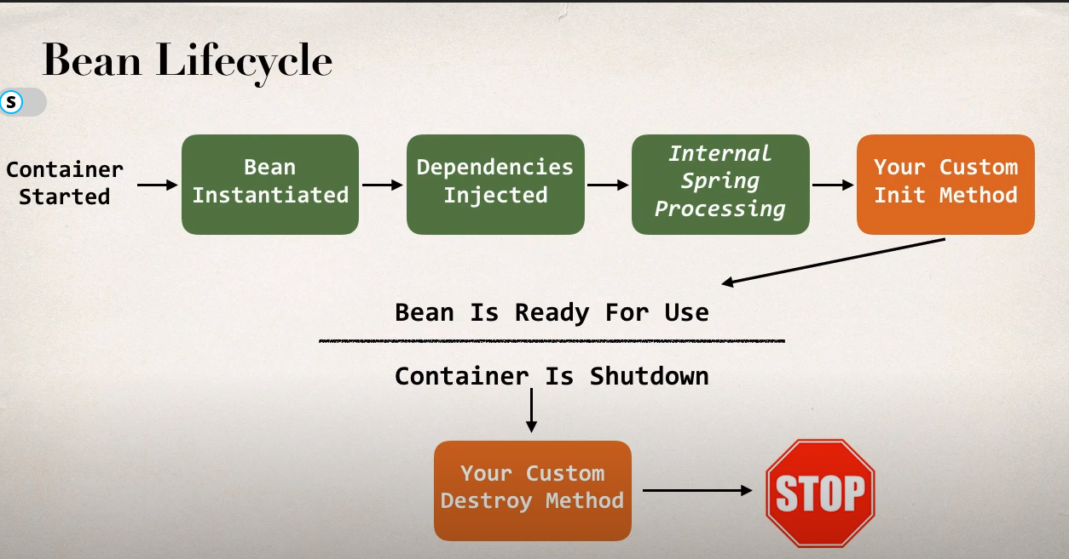

**Bean Lifecycle Methods /Hooks:**

* You can add custom code during **bean initialization**
  + Calling custom business logic methods
  + Setting up handles to resources (db, sockets, file etc)
* You can add custom code during **bean destruction**
  + Calling custom business logic method
  + Clean up handles to resources (db, sockets, files etc)

